**Data Driven Framework Implementation:**

Let’s implement data driven framework for posting three vehicles.

Create a new project “DataDriven” in Eclipse.

Create a folder “data” under this where we store the excel file with the data. Since we need images as well for posting a vehicle, create a separate folder “images” under “data” folder and put the different images here.

Create an excel sheet with name “vehicledata.xlsx” under this and enter the data for posting a vehicle under this. It should look like the following.

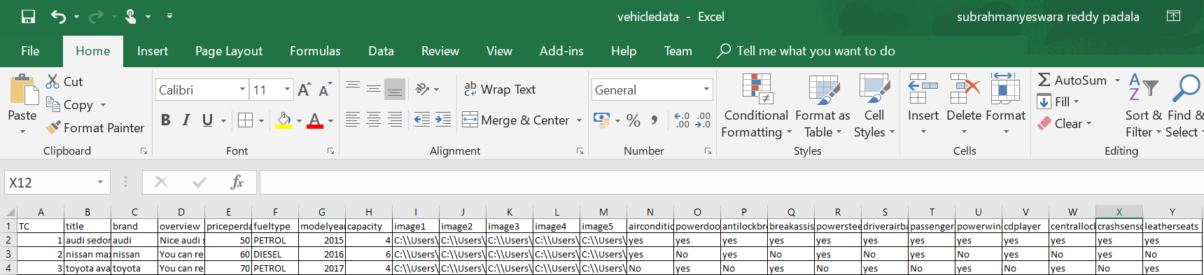

We have entered all the data in the excel sheet and we have mentioned the path for the images in the sheet. The data folder under the project should look like this.

